**FoodAdvisr Project Documentation**

**Stakeholders:** Kieran Lees (Co-founder AdvisrTech), Scott Verny (Co-founder AdvisrTech), Raju Bhupati (CEO Fire42), Venu Gopal (CTO Fire42), Paul Sreekar (Senior Lead), Sai Kumar (Senior Lead), Sushma (QA Lead) Ravi Teja (Web Services), Manvitha (Mobile Developer), Harshita (UI/UX Developer), Ashok (QA Associate), Sravan (Mobile Developer).

___________________________________________________________________________

|  |  |  |  |
| --- | --- | --- | --- |
| Document Modification History | | | |
| Version | **Date** | **Authors** | Description |
| 1.0 | 01/10/2017 | Sreekar | Initial Version |
| 1.1 | 20/10/2017 | Raju, Sreekar | Added recipe module |
|  |  |  |  |
|  |  |  |  |
|  |  |  |  |
|  |  |  |  |
|  |  |  |  |

**Project Description**

FoodAdvisr is a mobile application which will recommend food /food products to its users based upon their allergies, intolerances, favorites & predefined medical profiles.

**Service Need**

FoodAdvisr Tech has need for communicating its recommendations on food to its customers. Currently FoodAdvisr have an application, but lacks few functionalities required.

**Project Purpose & Scope**

The purpose of this project is to provide best food recommendations to FoodAdvisr users based upon their allergies, intolerances, favorites & predefined medical profiles at various restaurants & groceries around/desired location. Additionally, users can book a table/order food at restaurants. Can scan barcodes of products at groceries/menu’s at restaurants for suggestions.

**Technical Challenges / Issues**

Current FoodAdvisr application is able to grab information like user allergies, likes and dislikes, medical profile. But it lacks clean storyboard. The current application has clustered user interface. The current application also has issues to fix on android platform.

Tweaking the current application with our current process will likely cause application instability overtime. If we keep the current application, we will need to develop a plugin/module framework so we can keep the core coding of the application stable and updatable while also adding new features.

**Timeline**

|  |  |
| --- | --- |
| Review of Product | Oct 7, 2017 |
| Development and Internal Testing | Oct 30, 2017 |
| Beta Roll-Out | Nov 15, 2017 |
| Production Roll-Out | Nov 30, 2017 |
| Annual Review | Nov 30, 2018 |

**Requirements**

**Functional Requirements**

Primary:

1. Users can configure their allergies– foods that MUST be excluded from the user’s food for safety reasons
2. Users can configure ‘Include’ – food that the user needs in their diet for lifestyle or health reasons.
3. Users can configure ‘Exclude’ – food intolerances, for lifestyle or health reasons.
4. Users can configure their ‘Health Profiles’ – pre-built profiles by FoodAdvisr Nutritionist reflecting current best-practice guidance on ingredient inclusions and exclusions, as well as nutritional levels, for a variety of health conditions
5. User profile has to be created in backend based upon the user’s preferences on all of the above are merged.
6. As per user’s profile, FoodAdvisr provides a warning on selected food item (Contains Allergen, May Contain Allergen, Contains and Excluded Ingredient, Contains Included Ingredient, and level of match to nutritional profile settings)
7. Warnings to users represented by a color code – Black with A, Black with ‘May Contain’, Red with !, Green with thumbs-up, Red, Amber, Green)
8. Users can scan products at groceries for suggestions
9. Users can scan dishes in menu at restaurants.
10. User can place order against a table. (Dine In)
11. Use can pay through Payment Gateway (PayPal/Cash).
12. Portal for admin to manage the current application.
13. Admin can configure a restaurant.
14. Admin portal to manage multiple restaurants
15. Admin panel for signed up restaurants to upload their menu in detail with their ingredients.
16. Admin / Restaurant can configure company group name.
17. Admin / Restaurant can configure restaurant brand
18. Admin / Restaurant can configure restaurant location/address
19. Admin / Restaurant can configure list of named menus for that restaurant
20. Admin / Restaurant can configure configuration/structure/description/definition of each menu.
21. Admin / Restaurant can upload template excel sheet for above configuration of menu.
22. Dishes need to be imported in a standard format with Name, summary description, description, image, allergens contained, allergens may contain, ingredients, nutrition content. This needs to be the total values for the specific dish/recipe AND the values per 100g of the recipe.
23. Admin / Restaurant can Place order through portal of a restaurant

Secondary:

1. Admin can track number clicks on a restaurant as reports.
2. User can track order (Delivery).
3. User can give feedback against the order placed.
4. User can give rating against the order placed.
5. Admin can view analytics for Onboard/Pending restaurants.
6. Admin can view periodical sale analytics.
7. Admin can view grey restaurant clicks analytics.
8. Admin can view people completed settings analytics.
9. Admin / automated scheduler can review restaurant’s menu periodically(Weekly)
10. Admin module can capture last menu update Date.
11. Admin / automated scheduler confirmation through weekly email.
12. Admin / automated scheduler suspend restaurant, if it’s not up to date.

**Technical Requirement**

Primary:

1. Cross-platform support (Android and iOS).
2. Cross-browser / platform support for admin panel (IE, Firefox, Chrome, Safari – PC and Mac)
3. API with acceptable level of documentation.

Secondary:

1. Statistics and reporting.
2. User mobile application should be built using free open source software phoneGap.
3. Admin panel should be built using free open source software php.
4. RestAPI for mobile application should be built using open source software php, with laravel framework version 5.4.

**Policy Requirements**

Primary:

1. The system functionality will be driven by policy whenever possible.
2. The same policies apply to the mobile and desktop versions.

**Usability Requirements**

Primary:

1. FoodAdvisr mobile application will fully function on android devices with OS version 6 & above.
2. FoodAdvisr mobile application will fully function on iOS devices with OS version 8 & above
3. The admin panel will fully function in major browsers.

**Project Constraints**

***Time Constraints:*** We need the entire application to be available for beta-test by Nov 15, 2017 to prepare for Nov 30, 2017 rollout. The entire system needs to be in production on or before Nov 30, 2017.

***Scope constraints:*** This project will be limited to dealing to solely with the software installation/upload to stores (google play for android & appstore for iOS), customization, and implementation. Once the project is complete, the work will need to enter into maintenance cycle.

**Communication Plan**

***Internal Communication:*** weekly reviews will be held on progress of the task force. Monthly or priority based communication will be held with client.

**Project Overview**

**Use case diagram for FoodAdvisr Application:**

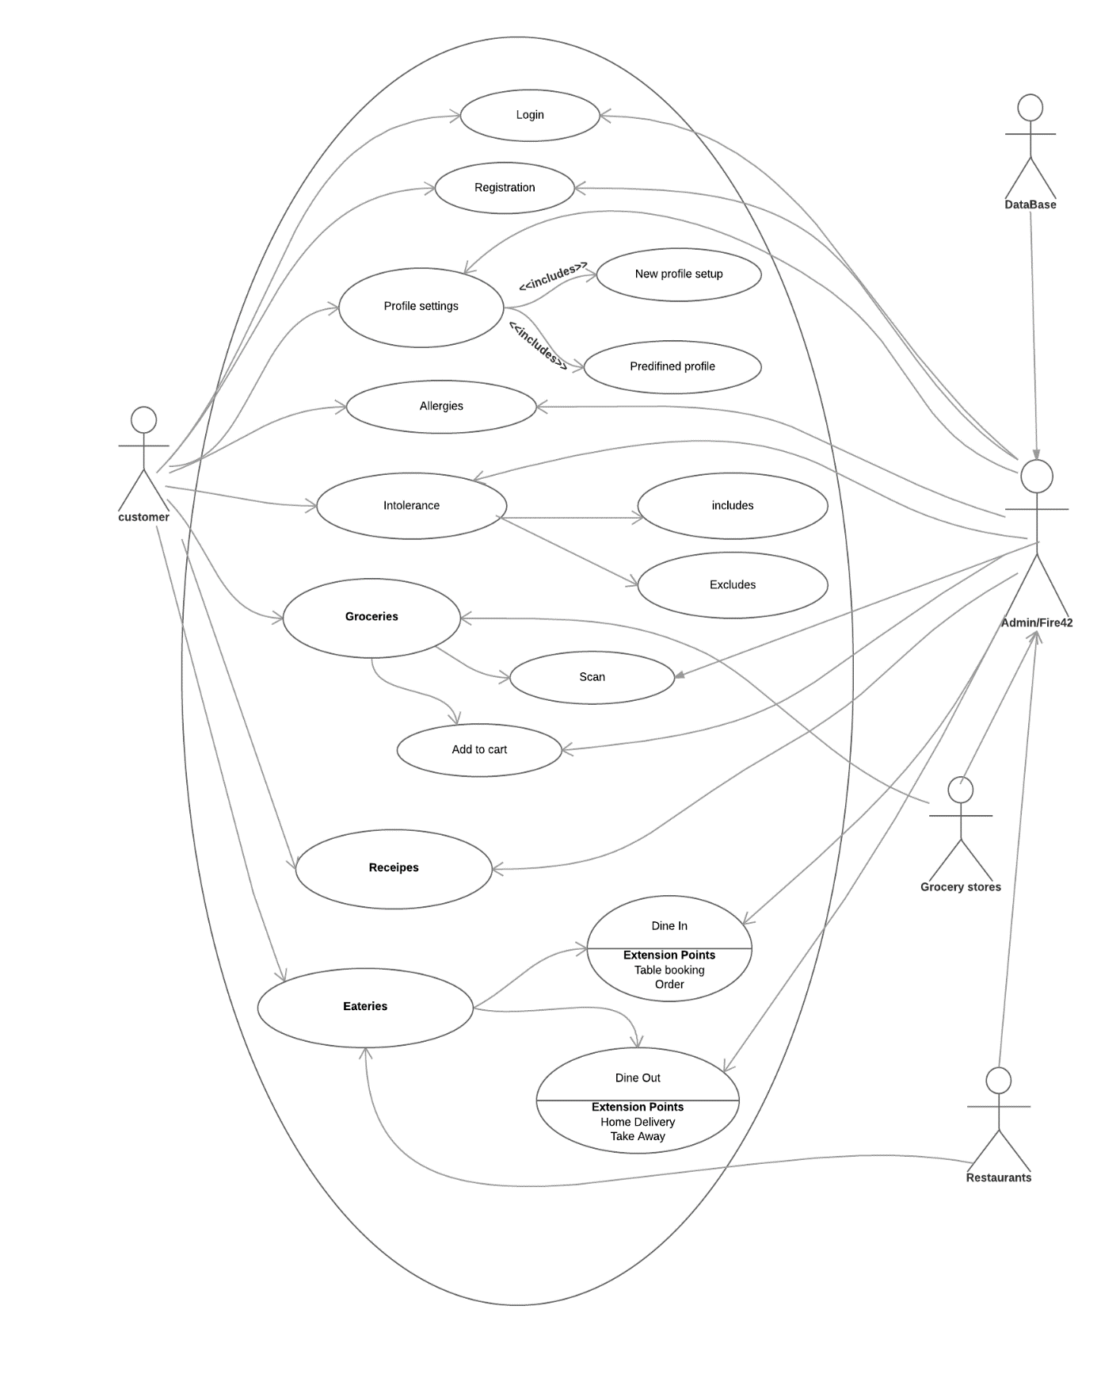

**Activity Diagram for FoodAdvisr customer (Mobile Application):**

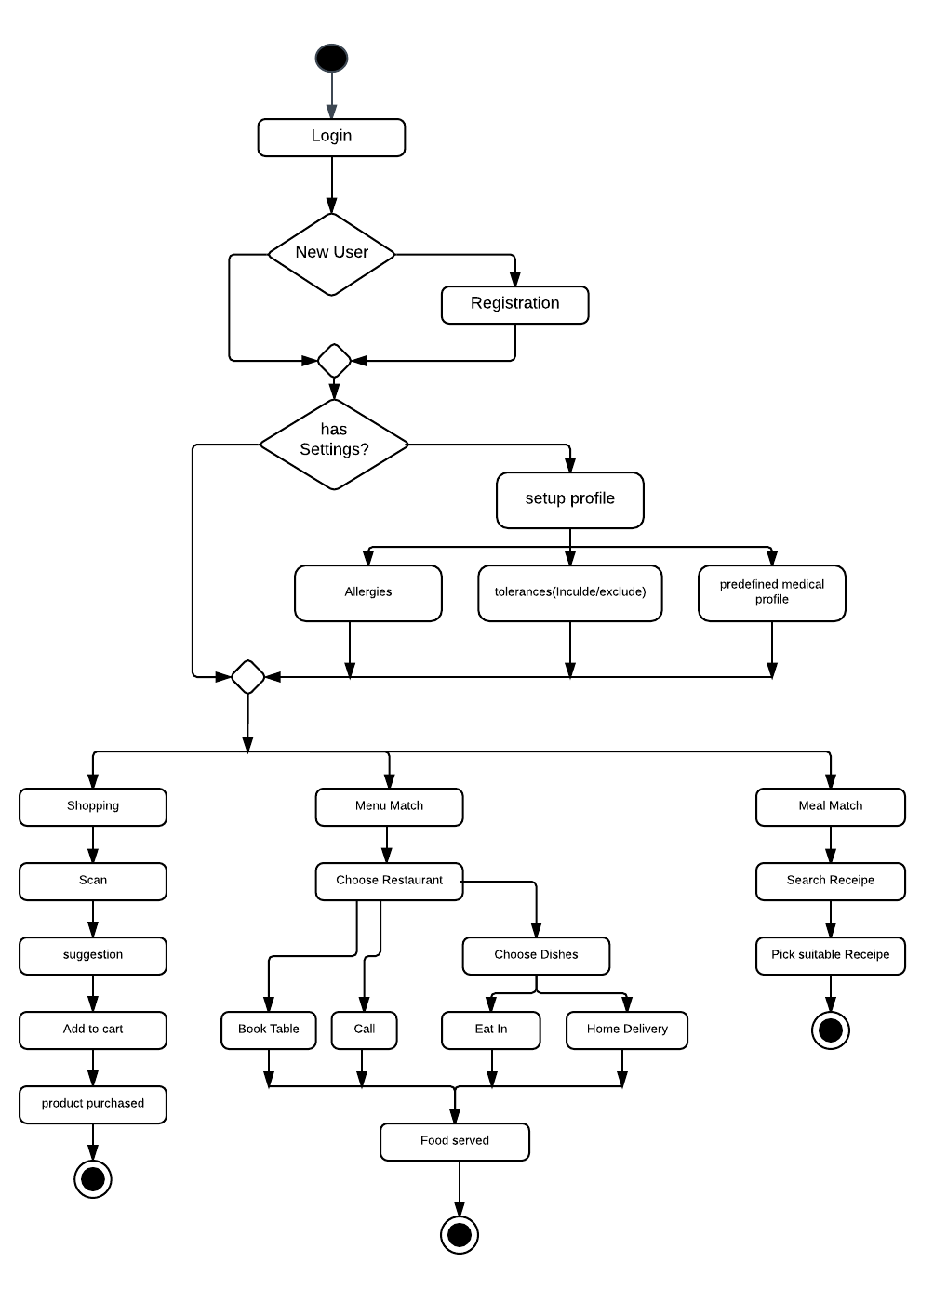

**Activity Diagram for restaurant admin**

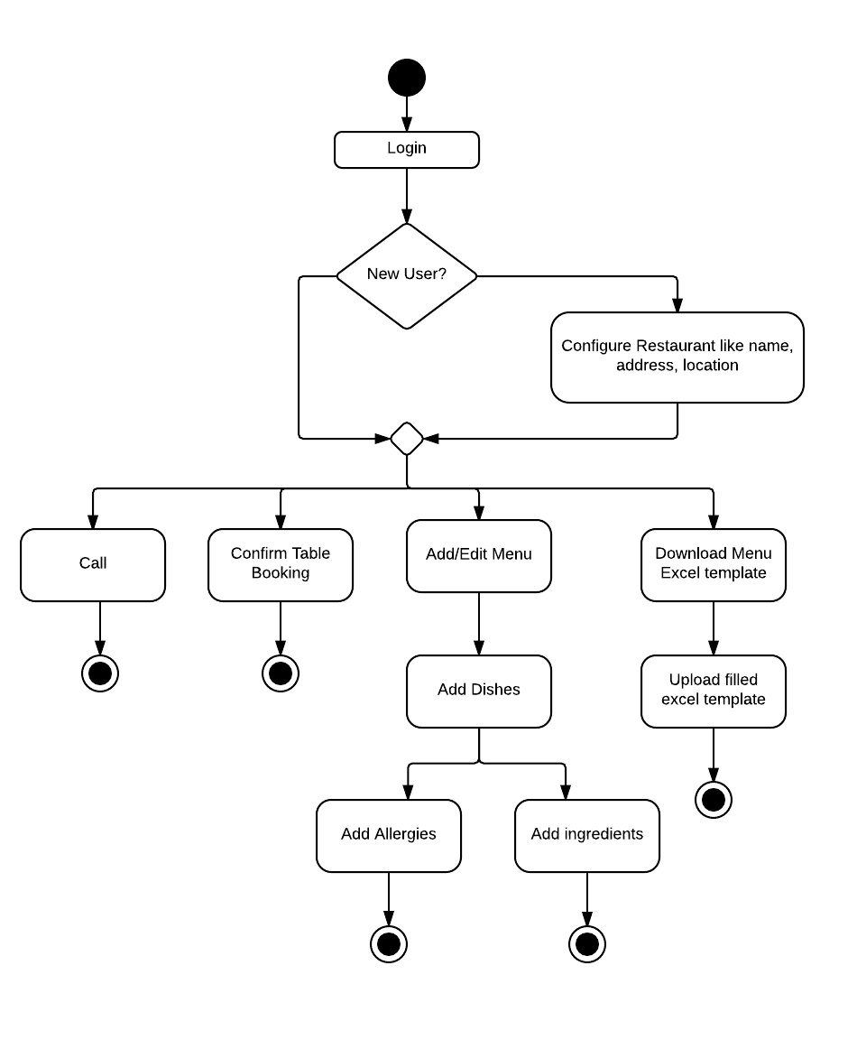

**Activity Diagram for super admin**

